DS ASSIGNMENT -1
Aim:The growth of supermarkets in the most populated cities is increasing and market competitions are also high. The dataset is one of the historical sales of a supermarket company which has been recorded in 3 different branches for 3 months data.
- Bar cha
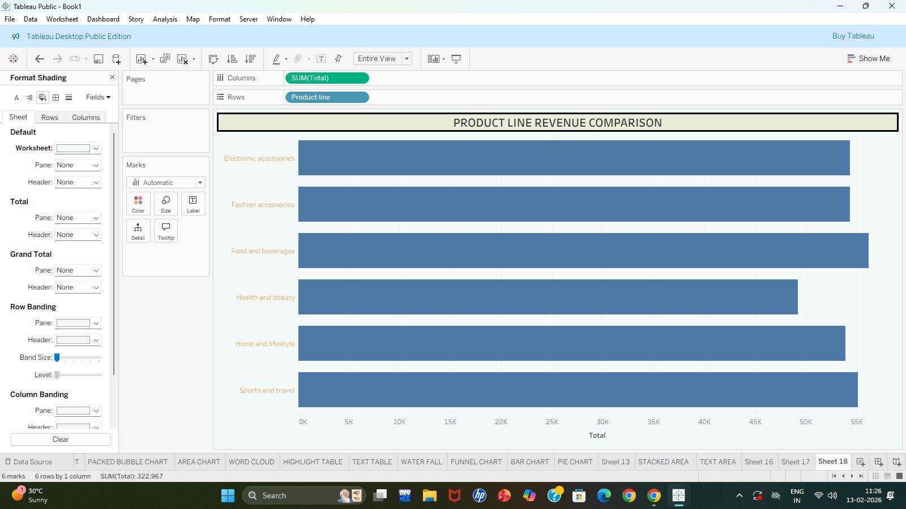
- Pie chart
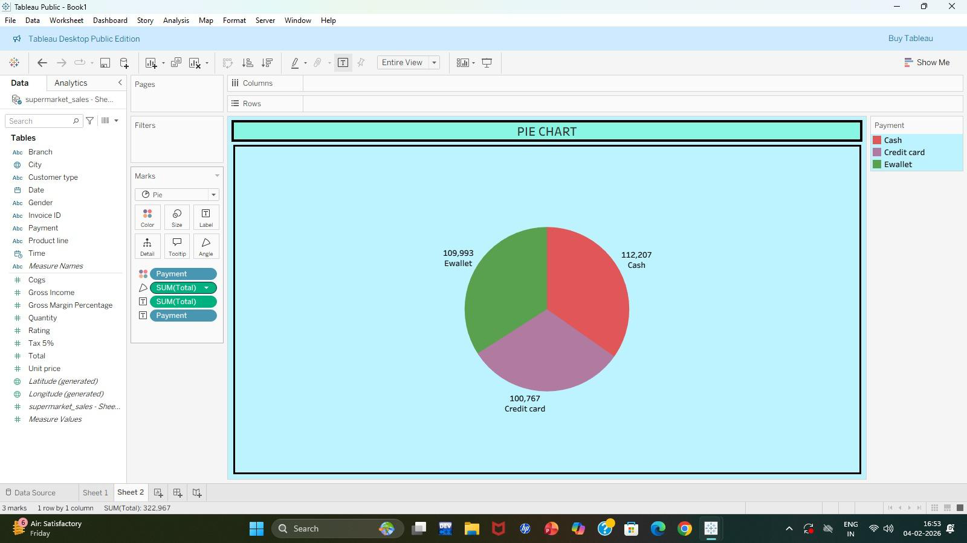
- Stacked bar
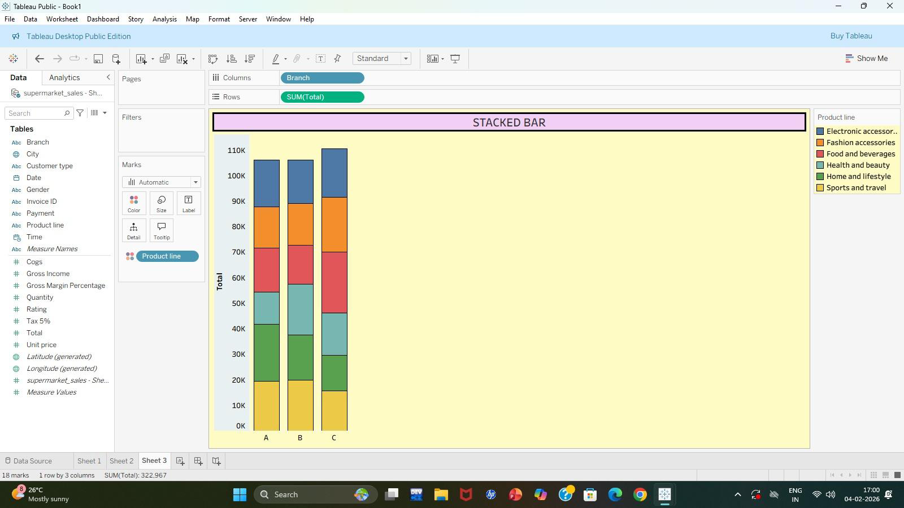
- Line chart
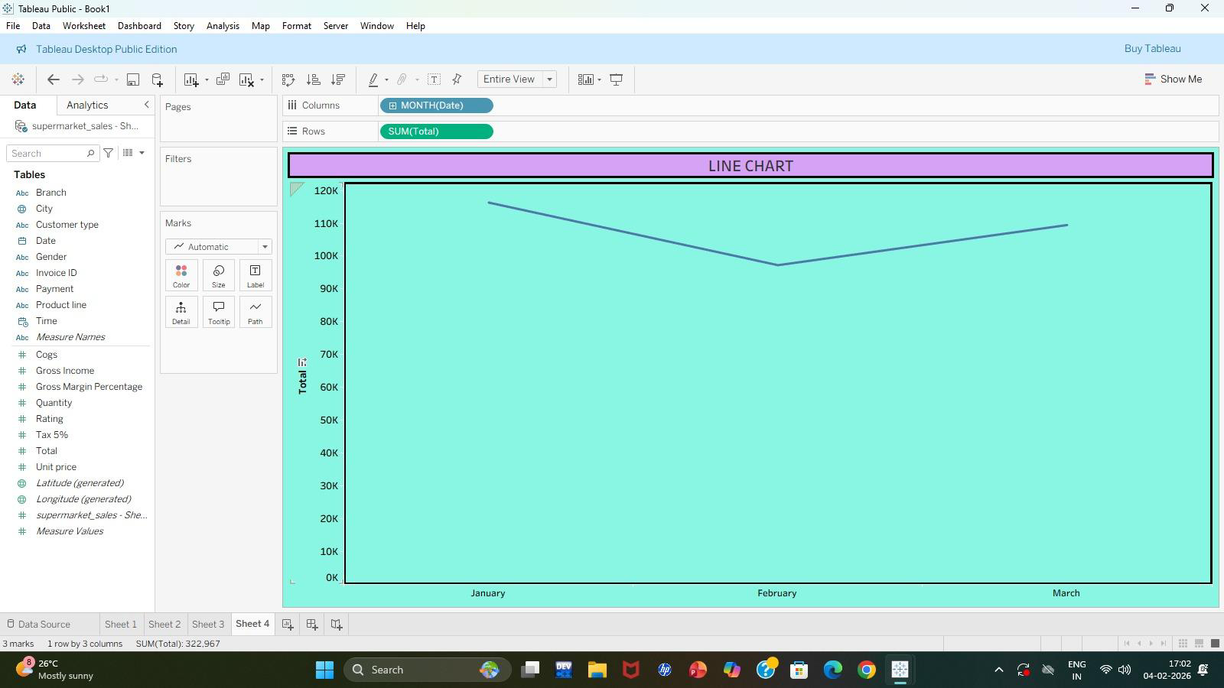
- Bubble chart
